**The Battle of the Neighborhoods**

**Exploring NYC Neighborhoods for Caribbean Restaurants**

**Introduction**

**Background**

New York City the largest and most influential American metropolis, encompassing Manhattan and Staten islands, the western sections of Long Island, and a small portion of the New York state mainland to the north of Manhattan. New York City is a collection of many neighborhoods scattered among the city’s five boroughs—Manhattan, Brooklyn, the Bronx, Queens, and Staten Island—each exhibiting its own lifestyle. The population consists of representatives of some 200 national groups, making it one of the most ethnically diverse cities in the world. Therefore, it is safe to say that the cuisine of New York City comprises many cuisines belonging to the various ethnic groups.

**Problem**

Like New York City, the Caribbean Islands comprise people from the world over. The various waves of migration have formed a truly unique blend of cuisines and traditions in the region. The cultural confluence in Caribbean cuisine has turned the Caribbean islands into a food lovers’ paradise. This project will set out to explore New York City for Caribbean Restaurants. The aim is to locate Caribbean restaurants in New York City and find the ones that are highly rated.

**Interest**

The results can be utilized by persons looking to experience Caribbean Islands cuisine in New York City.

**Data**

New York Neighborhood Dataset- Link: <https://cocl.us/new_york_dataset>

Foursquare API - Link: <https://enterprise.foursquare.com/products/places>

**Methodology**

The Methodology section will describe the main components of our analysis.

<https://cocl.us/new_york_dataset>)

This Neighborhood has a total of 5 boroughs and 306 neighborhoods. To explore the neighborhoods, we will essentially need a dataset that contains the 5 boroughs and the neighborhoods that exist in each borough as well as the latitude and longitude coordinates of each neighborhood. This dataset is downloaded using the mentioned URL <https://cocl.us/new_york_dataset>

Next, we are going to start utilizing the Foursquare API to explore the neighborhoods. We will send a request to the API to search for a specific type of venue, to explore a particular venue, to explore a geographical location, and to get venues ratings.

Then we will use the visualization library, Folium, to visualize the results. I will use python folium library to visualize geographic details of NYC and its boroughs and highlight on the map, the top rated boroughs for Caribbean Restaurants using labels.

**Download and Explore New York Dataset**

The New York Neighborhood dataset is downloaded using the mentioned URL.

Once the .json file is downloaded, it is analyzed to understand the structure of the file. A python dictionary is returned by the URL and all the relevant data is found to be in the features key, which is basically a list of the neighborhoods. The dictionary is transformed into a pandas dataframe by looping through the data and filling the dataframe rows one at a time.

As a result, a dataframe is created with Borough, Neighborhood, Latitude and Longitude details of the New York City’s neighborhood.

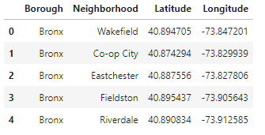

A plot of the NYC boroughs and neighborhoods is generated in a bar chart

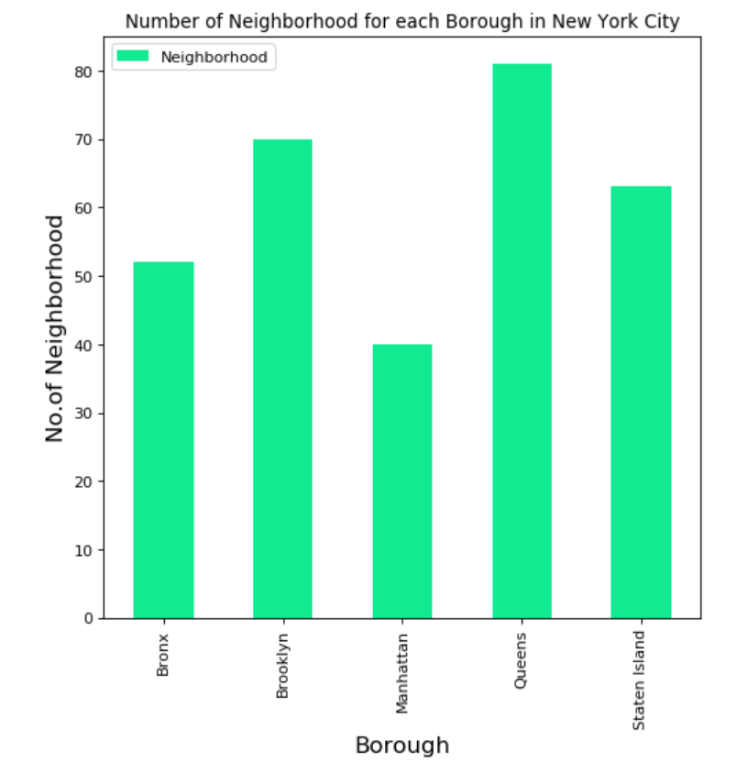

**Foursquare API**

The Foursquare API is used to explore the neighborhoods and segment them. To access the API, ‘CLIENT_ID’, ‘CLIENT_SECRET’ and ‘VERSION’ is defined.

To explore the neighborhoods for ‘Caribbean Islands restaurants’, Foursquare Venue Category Hierarchy is retrieved and returned request is further analyzed.

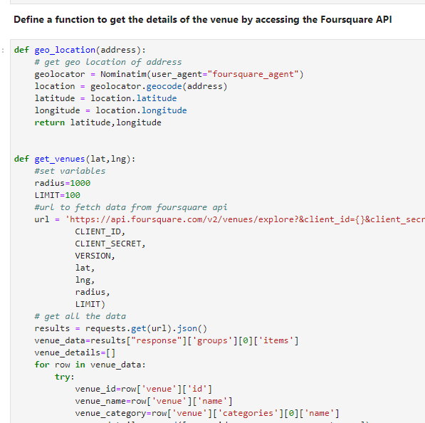

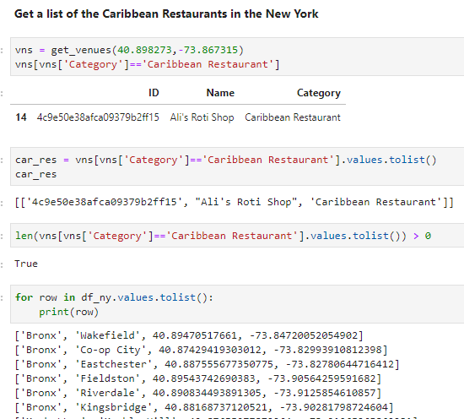

A list of the Caribbean restaurants in NYC boroughs/neighborhoods is generated

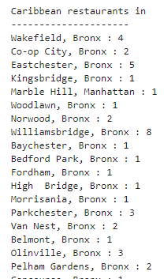

The returned ‘dataframe’ is as follows:

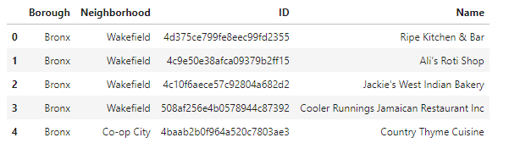

Visualization of the restaurants in each borough in NYC

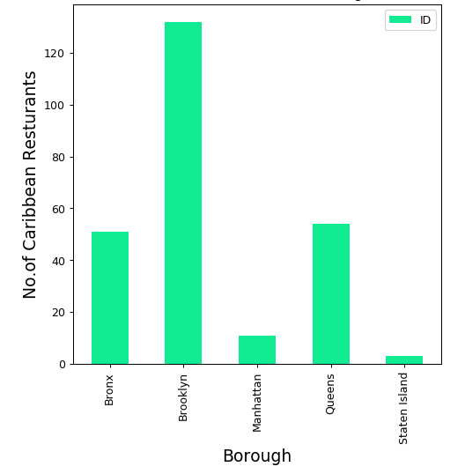

Visualization of the neighborhoods with the highest number of Caribbean restaurants (top 15)

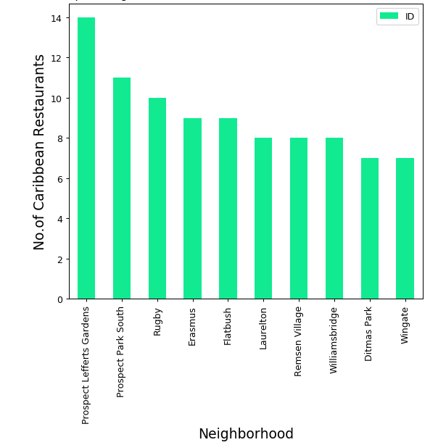

Acquire the tips and get the rating of the Caribbean restaurants in NYC

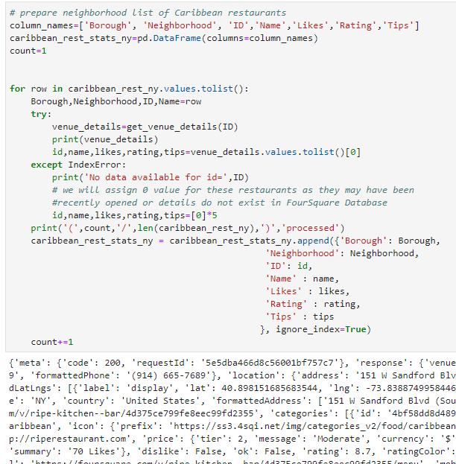

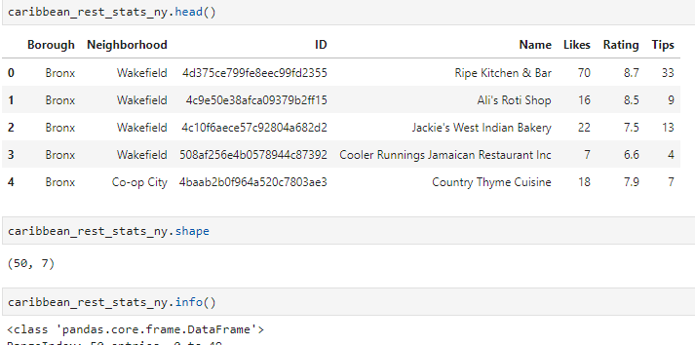

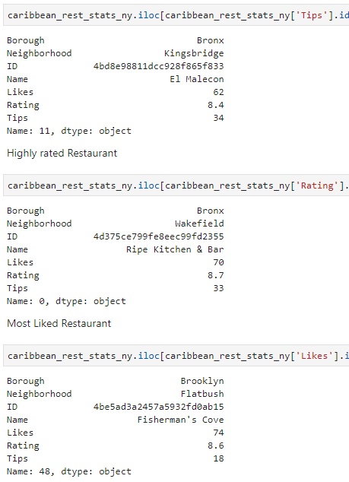

Finding the average rating of the restaurants –

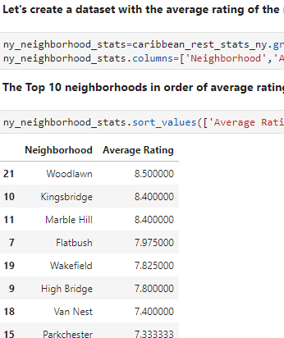

Neighborhoods with average rating greater than or equal to 8.0

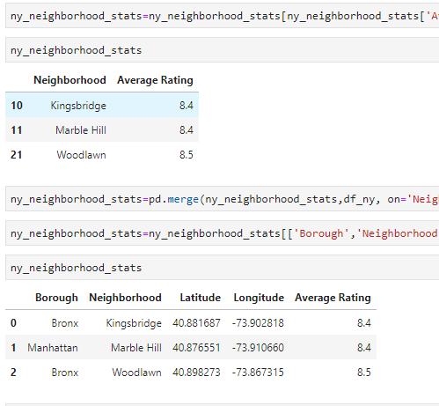

Let’s see these top 3 areas on a map

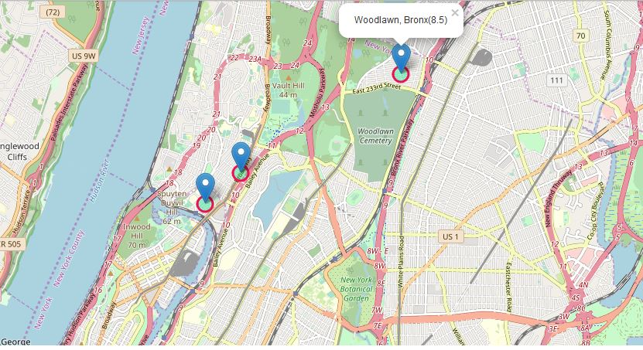

**Results / Discussion**

Based on the Data Analysis and Visualization, we can conclude the following:

* The Caribbean restaurants in the Bronx and Manhattan are highly rated (greater or equal to 8.0)
* The Borough with the highest number of Caribbean restaurants is Brooklyn
* The neighborhood in Brooklyn with highest number of Caribbean restaurants is Prospect Lefferts Gardens
* The Borough of Staten Island has the least number of Caribbean restaurants
* The Caribbean restaurants in Woodland, Bronx is the highest rated

**Conclusion**

Using the resources learned on this course, I was able to explore, analyze and visualize data. I wish to thank Coursera for helping me acquire these new skills.